Date:22/1/2026
7. Create a Virtual Machine with 1 CPU, 2GB RAM and 15GB storage disk using a Type 2 Virtualization Software, using virtual box.

AIM
To create a Virtual Machine with 1 CPU, 2GB RAM, and 15GB storage using a Type-2 Virtualization Software (VMware Workstation / VirtualBox).

SOFTWARE USED
- Host Operating System – Windows 10 / Windows 11
- Virtualization Software – VMware Workstation (Type-2 Hypervisor)
- Guest Operating System – Windows 11 (64-bit ISO)

PROCEDURE
1. Install Oracle VM VirtualBox on the host system.
2. Launch VirtualBox after successful installation.
3. Click on New to create a new virtual machine.
4. Enter the name of the virtual machine and select the type and version of the guest operating system.
5. Allocate 2 GB (2048 MB) RAM to the virtual machine.
6. Set the CPU count to 1 under processor settings.
7. Create a virtual hard disk and set its size to 15 GB.
8. Choose the hard disk file type (VDI) and allocation method (Dynamically allocated).
9. Complete the VM creation process.
10. Attach the Guest OS ISO file to the virtual optical drive.
11. Start the virtual machine.
12. Follow the on-screen instructions to install the guest operating system.
13. After installation, verify the VM settings (CPU, RAM, and storage).
14. Shut down or restart the virtual machine as required

Output
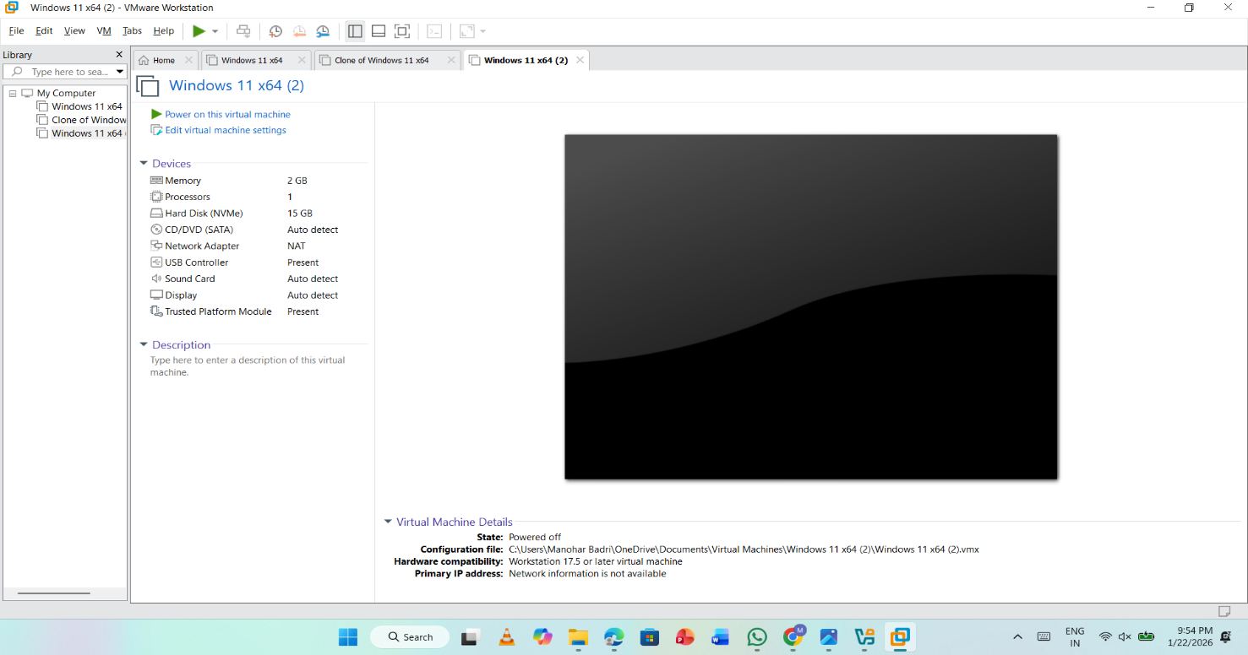

Result
Thus, a Virtual Machine with 1 CPU, 2GB RAM, and 15GB storage was successfully created using Type-2 Virtualization Software (VMware Workstation).

